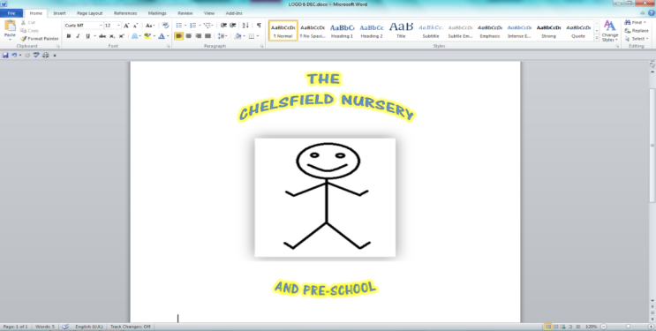



Web site: thechelsfieldpre-school.com

Email: chelsfieldbrom@yahoo.co.uk

**Rated good June 2017**

The Chelsfield Nursery and Pre-school

Admissions Policy

We operate an inclusion and equality policy and ensure that all children have access to nursery places and services irrespective of their gender, race, disability, religion or belief or sexual orientation of parents.

1. Children are offered a place on a first come first served basis and we do not have a waiting list should a child not be of an age to attend but wish to register then only their name and dob are kept on file along with the requested date of attendance.
2. Deposits are only used to secure a place within the Nursery and never for children attending Pre-school only hours, this deposit is returned via a discount on the 3rd months completed payment.
3. Children are offered places first if their siblings are already at the setting then in order of the date in which their application has been received, SEN or children with physical disabilities are offered a place as soon as a place is available,

Prior to a child attending this setting, parents must:

* give a copy of the child’s birth certificate,
* complete and sign a Parent Contract – stating the hours your child attends. This is an agreement to allow us to claim the government funded place.
* sign our terms and conditions in our admission form. These forms provide the setting with personal details relating to the child. For example, name, date of birth, address, emergency contact details, parental responsibilities, dietary requirements, collection arrangements, fees and sessions, contact details for parents, doctor’s contact details, health visitor contact details, allergies, parental consent and vaccinations etc.

**Providing government funded places** – 2-year-old funding, universal 15 hours and extended entitlement (30 hours)

All funded sessions are in line with the Government’s Statutory Guidance and Local Authority requirements. When you register your child for their funded place we will discuss your needs, and as far as possible with availability and staffing arrangements we will accommodate your wishes. We will try to accommodate hours needed or if changes to hours are needed but this should be booked in advance.

Free Offer **& charges for additional time and/or consumables**

**The Chelsfield nursery and preschool**

**Offer is**

**Option 1**

|  |  |  |  |  |  |  |
| --- | --- | --- | --- | --- | --- | --- |
| **Funded Places for 2, 3 & 4 year old funding** | | | | | | |
| Option 1 | | **2 year old funding** | **3&4 Univ 15 hours** | | | **30hours (ext)** |
| **Free Offer – available Monday to Friday & 38 weeks of the year** | | **9.15-12.15/13.15-16.15**  **5 days per week** | **9.15-12.15/13.15-16.15**  **5 days per week** | | | **9.15am –12.15 13.15-16.15pm**  **5 days + Lunch 1 hour option.** |
| **Charges** | | | | | | |
| **Consumables\*** | | **AM session £1.75** | **PM session £2.75** | **Lunch £3.75** | | **Full day £8.25** |
| **Early Morning** | | **7am – 8am = £10.00** | | | | |
| **Additional hours** | | **£7.25p per hour/ £36.25 for ½ day/** | | | | |
| **Lunch hour** | | **£7.25** | | | | |
| **Standard Day Rate** | | **8am – 6pm =£70.00** | | | | |
| **\*Consumables are:- healthy breakfast, snacks and lunch and tea/dinner, wipes, tissues etc.** **If parents want to bring in their own consumables, they should request more detailed information about what they will need to provide** | | | | | | |
| **Option 2** | | | | | | |
| **Flexible Options:** | | **Term time only** | | | | |
| **Half day sessions (5 hours)**  **8am to 1pm or 1pm to 6pm** | | | **All day sessions (10 hours)**  **8am to 6pm** | | | |
| **Including 1 hour free £30**  **Including 2 hours free £25**  **Including 3 hours free £20**  **Including 4 hours free £15** | | | **Including 5 hours free £45**  **Including 6 hours free £40**  **Including 7 hours free £35**  **Including 8 hours free £30**  **Including 9 hours free £25** | | | |
| **Option 3** | | |  | | | |
| **Extended term time** | | | **15 hour (Univ)** | | **30 hours (ext)** | |
| **Free Offer – available Monday to Friday & 48 weeks of the year** | **8.00-18.00 5 days per week** | | **Sessional rate £58.13p** | | **Sessional rate**  **£46.25p** | |

This policy adopted by The Chelsfield Nursery and pre-school

On February 2023

Review date February 2024

Signed

Name Gary carter Director