······················•·················�······································4

,..,,..,, -..ll
71'"",

The Chelsfield Preschool and Nursery Newsletter October 2022

Dates to remember

End of term for Preschool children Friday 21st October. Our Half Term Monday 24th until Friday 28th October. Nursery children to attend throughout this period if required.

Preschool Children return Monday 31st October. End of term for all children Friday 16th December 2022.
All children return Tuesday 3rd January 2023.

Our theme for October is Healthy body, Healthy Mind. We have made fruit Kebabs to celebrate Yorn Kippur and will be making Cardamon biscuits to celebrate Diwali and the children will be planting tulip bulbs for their growing this month. We are celebrating Yorn Kippur, Diwali and Halloween.

We would like to remind all parents to look at our parent board display by the backdoor. It provides you with a lot of information throughout each month.

Gentle Reminders

Please do not use the Car park after 9 am to ensure everybody stays safe. Children need to arrive no later than 9.30am unless otherwise agreed in advance with management. If for any reason a situation arises, please call the Nursery to let us know. As you are aware all children's absences need to be recorded. Please call or email if your child is unable to attend.
Please ensure the children bring a bag each day, supplying spare clothes, nappies, wipes if needed and ensure we have their named water bottle on a daily basis. The children will also need a named winter coat, as we will always use the garden, weather permitting.

If you haven't already supplied us with a family photo, please email these as they are placed on our community wall enabling the children to share their family with their peers and talk about home. Please can all Nursery children have a small bag with toothbrush and paste for teeth brushing after Tea. We would much appreciate it if parents have any unwanted craft resources like tape, paper. Card etc. would you be happy to donate these to the nursery.

Please always remember we are here to talk to at any time. Please see below information for families if you require support. The family centre’s and the children’s project are local and here to help. Please have a look at the services they provide. Please see overleaf.

Parents Evening

We are hoping to arrange a Parents Evening before we break up for Christmas. We will confirm the date shortly. Thank you for your support!

The Chelsfield Nursery Team

•••••••••••••••••••••••••••••••••••••••••••••••••••••••••••••••••••••••••••••••

m ;�y;

The Chelsfield Preschool ancl Nurse Newsletter October 2022

Further Information about the services they provide are available on our parent Board or alternatively you can speak to a member of the team.

0 The Bromley Children's Project
The Bromley Children's Project

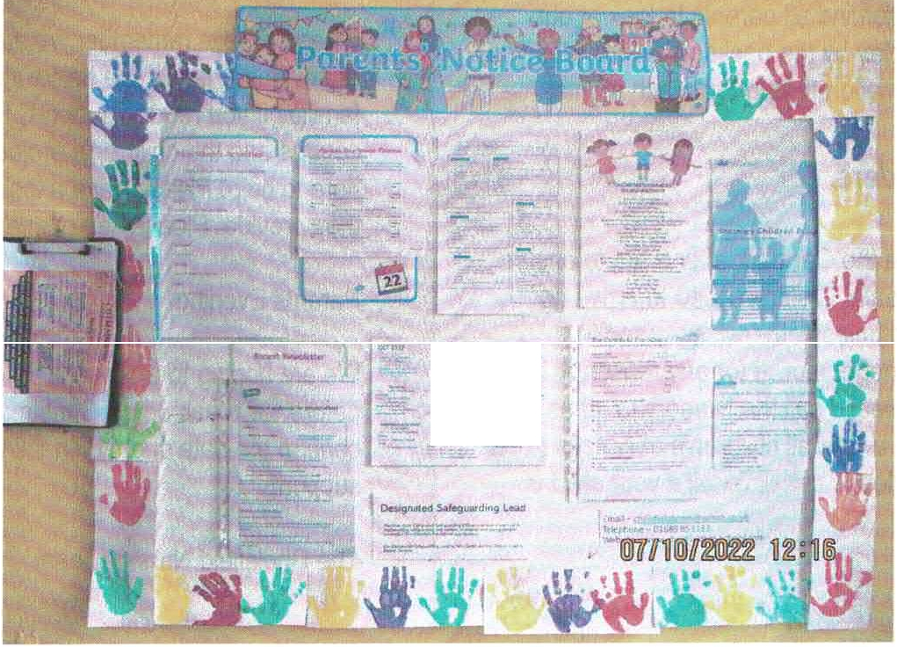a The Bromley Children's Project

it·!-•";· ' f- ? -

- ·-r

-- $ -::-:�l•C

Blenheim Children and Family Centre

Email - BLENHEIMCFC@BROMLEY.GOV.UK Phone - 01689 831193

Cotmandene Family Centre

Email- COTMANDENECFC@BROMLEY.GOV.UK Phone - 0208 300 2548

