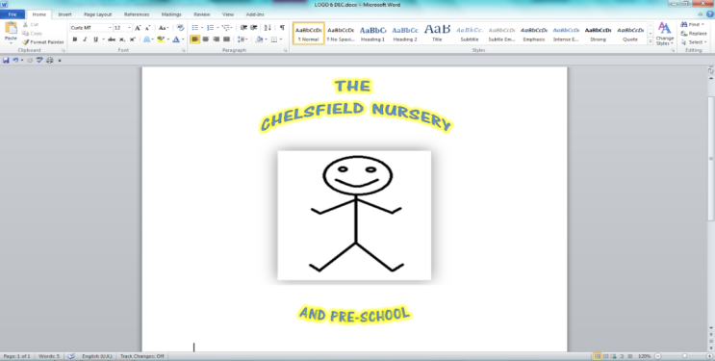



Web site: thechelsfieldpre-school.com

Email: chelsfieldbrom@yahoo.co.uk

**Rated good June 2017**

Information sharing policy and protocol

(2018 GDPR compliant)

**Our most important consideration is whether sharing information is likely to support the safeguarding and protection of a child**.

Here at the Chelsfield nursery we adhere closely to the conditions set out in the Bromley Multi agency children’s safeguarding information sharing protocol, and work within the 7 golden rules set out within.

Set out below are the Principles within which we work to make decisions whether and with whom we share information

**Is the information;**

**Necessary and proportionate**

When taking decisions about what information to share, we consider how much information we need to release. Not sharing more data than is necessary to be of use is a key element of the GDPR and Data Protection Act 2018, and we always consider the impact of disclosing information on the information subject and any third parties. Information must be proportionate to the need and level of risk.

**Relevant**

Only information that is relevant to the purposes should be shared with those who need it. This allows others to do their job effectively and make informed decisions.

**Adequate**

Information should be adequate for its purpose. Information should be of the right quality to ensure that it can be understood and relied upon.

**Accurate**

Information should be accurate and up to date and should clearly distinguish between fact and opinion. If the information is historical then this should be explained.

**Timely**

Information should be shared in a timely fashion to reduce the risk of missed opportunities to offer support and protection to a child. Timeliness is key in emergency situations and it may not be appropriate to seek consent for information sharing if it could cause delays and therefore place a child or young person at increased risk of harm. Practitioners should ensure that sufficient information is shared, as well as consider the urgency with which to share it.

**When and how we share information**

When asked to share information, we consider the following questions to help us decide if, and when, to share. If the decision is taken to share, we will consider how best to effectively share the information. (There is a flowchart in the LBB guide in our policy folder following this policy)

**When**

Is there a clear and legitimate purpose for sharing information?

• Yes – see next question

• No – do not share

Do you have consent to share?

• Yes – you can share but should consider how

• No – see next question

Does the information enable an individual to be identified?

• Yes – see next question

• No – you can share but should consider how

Have you identified a lawful reason to share information without consent?

• Yes – you can share but should consider how

• No – do not share

**How**

• Identify how much information to share

• Distinguish fact from opinion

• Ensure that you are giving the right information to the right individual

• Ensure where possible that you are sharing the information securely

• Where possible, we will be transparent with the individual, informing them that that the information has been shared, if doing so does not create or increase the risk of harm to the individual.

All information sharing decisions and reasons must be recorded in line with our organisation and local procedures. If at any stage we are unsure about how or when to share information, we will seek advice on this. At all times we ensure that the outcome of the discussion is recorded.

**Secure**

Wherever possible, information should be shared in an appropriate, secure way. Practitioners must always follow their organisation’s policy on security for handling personal information.

**Record**

Information sharing decisions should be recorded, whether the decision is taken to share. If the decision is to share, reasons should be cited including what information has been shared and with whom, in line with organisational procedures. If the decision is not to share, it is good practice to record the reasons for this decision and discuss them with the requester. In line with each organisation’s own retention policy, the information should not be kept any longer than is necessary. In some rare circumstances, this may be indefinitely, but if this is the case, there should be a review process scheduled at regular intervals to ensure data is not retained where it is unnecessary to do so.