

**Rated good June 2017**

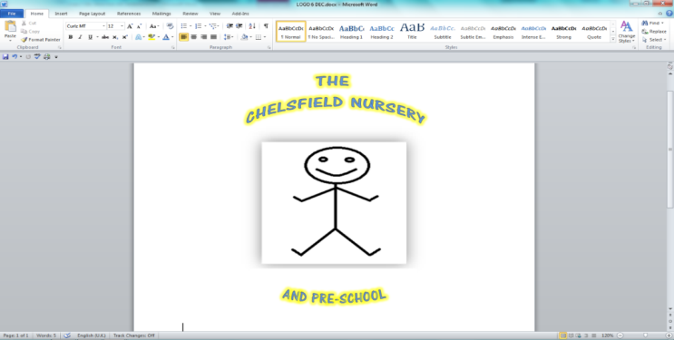

Dear Parent

Due to the recent changes brought in by the update to the data protection act, now known as the General data protection regulations (GDPR)

All new and existing parents/carers wishing to supply proof of age of a child by supplying us with a passport, must sign to give permission for us to hold and pass this information to the relevant authority dealing with the funding of your child.

**“I give permission to The Chelsfield Pre-school/nursery and the London Borough of Bromley to retain a copy of this page of my child’s passport for the purpose of proof of age for Free Entitlement Funding (2, 3- & 4-year-old year olds).**

**Signature…………………………………… Date………………………**

**Print Name………………………………………………**

Yours Julie Carter ( Manager/Owner)

For The Chelsfield Nursery and Pre-school.